Develop A Mobile Application Using MIT app

Use Dashboard Nodes For Creating UI (Mobile App)

|  |  |
| --- | --- |
| Date | 11 November 2022 |
| Team ID | PNT2022TMID45387 |
| Project Name | Project – Gas leakage monitoring and alerting system for industries |

Step 1: Generated link is pasted

<https://node-red-bwjoz-2022-11-10.eu-gb.mybluemix.net/sensor>

<https://node-red-bwjoz-2022-11-10.eu-gb.mybluemix.net/control?command=Light%20on>

<https://node-red-bwjoz-2022-11-10.eu-gb.mybluemix.net/control?command=Light%20off>

<https://node-red-bwjoz-2022-11-10.eu-gb.mybluemix.net/control?command=Sprinkle%20on>

<https://node-red-bwjoz-2022-11-10.eu-gb.mybluemix.net/control?command=Sprinkle%20off>

Step 2: Paste the links in the sensor and button blocks and the results of blocks of backend is shown

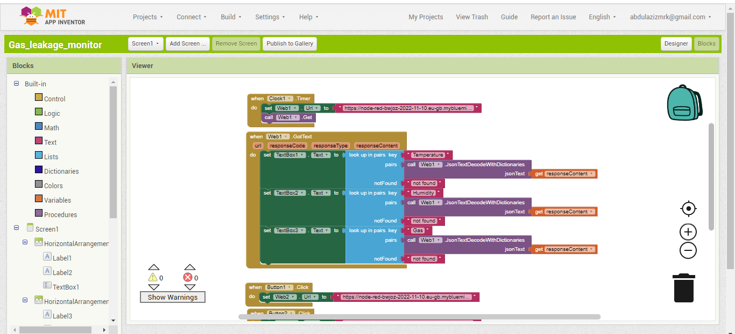

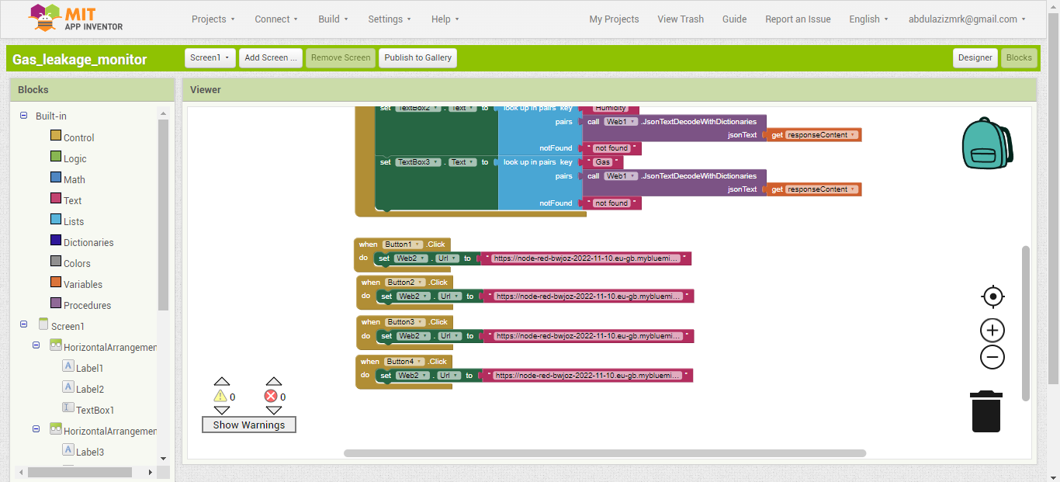

Step 3: The final input using MIT app inventor is displayed:

